W23/S24
Misuse of Slots Enforcement Code
Annual Report – 2023/2024

- Introduction

ACL is the UK’s designated airport slot coordinator. We work with 75 airports across the globe to ensure efficient use of capacity and better operational performance for the benefit of airport operators, airlines and passengers.

Part of ACL’s regulatory function is to monitor the use of slots to identify misuse at the UK’s coordinated airports. This is an important contributor to ensuring fair and efficient access to limited airport resources. The aim of monitoring and enforcement is to encourage operators to improve their slot performance at airports through better scheduling and operations and thus to contribute to smoother, more efficient airport operations. This benefits all operators and their customers, the travelling public and freight shippers.

This report covers the period 01 October 2023 to 30 September 2024 and covers the Winter 2023 and Summer 2024 IATA seasons.

Information on how ACL monitors and investigates slots misuse, how we take enforcement action against misuse and carrier’s rights can be found on the ACL website at https://www.acl-uk.org/slot-sanctions/

- Monitoring Activity

ACL’s monitoring process is explained on our web site (https://www.acl-uk.org/slot-sanctions/).

The figures below provide insight and detail into the number of queries sent by ACL by season, airport and type of misuse. The S24 season sees the introduction of Bristol Airport into full level 3 status and the beginning of slot monitoring activities by ACL with a small number of enquiries sent in the summer season. Leeds Bradford Airport also became level 3 during the night period only, however no enquiries were made to airlines by ACL for this primitive season.

As seen in Figure 1, queries sent in S24 at majority of airports were down compared with S23. This would imply the slot performance of airlines has been positive across UK airports in the summer season.

Figure 4 shows the number of adhoc enquiries sent to airlines this summer season was greater than seasonal enquires compared to S23. With Figure 3 showing the split between types of misuse mirrored that of the previous summer.

During the period of this report, slot monitoring and sanctions activity at BRS, LBA and MAN Airports has been affected by challenges in receiving suitable slot monitoring data. Basic monitoring activity has taken place during the period and ACL are working with the airports to rectify this situation moving forward.

Figure 1. Total queries sent by ACL by UK airport – Summer seasons
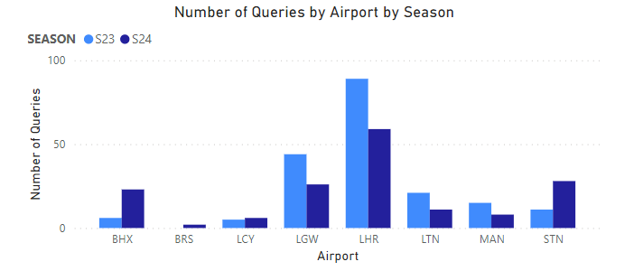

Figure 2. Total queries sent by ACL by UK airport – Winter seasons
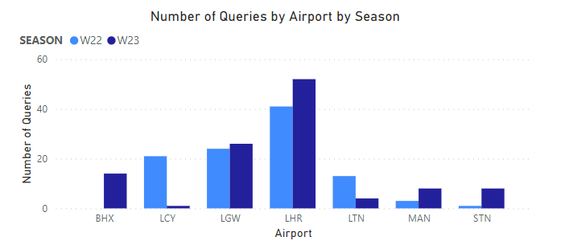

Figure 3. Types of misuse in queries sent by ACL by season in percentage.
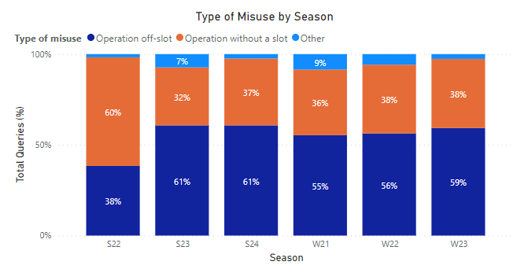

Figure 4. Operational type sent by ACL in queries by percentage.
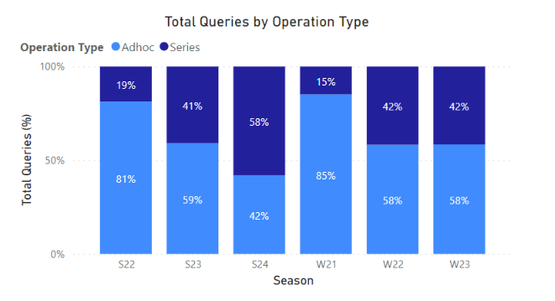

Figure 5. Types of misuse by Airport sent in queries by ACL.
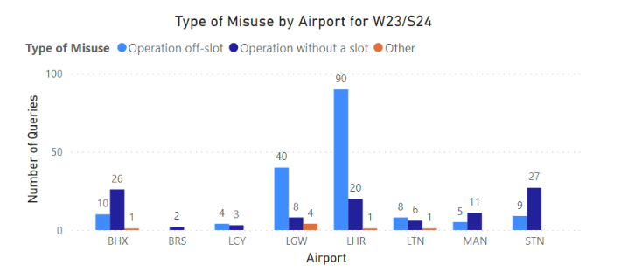

- Examples of corrective action facilitated by ACL’s monitoring activities

Where possible, ACL engages with carriers to encourage behavioural change to improve future slot performance without the need to formally sanction misuse. This could be increasing block times, retraining of the out of hours process at individual airports or equipment discrepancies such as using a different aircraft to declared slot. Below are a few examples of carriers behavioural changes that have improved slot performance after slot monitoring activities by ACL were highlighted to the carrier.

In S24 at Birmingham Airport after ACL highlighted the off-slot performance of an Air France flight, the block time was adjusted mid-season. This improved the performance of the flight for the remaining of the S24 season.

A second example of corrective action can be seen at London Gatwick Airport in W23 by Volotea Airlines. A ground time adjustment of 10 minutes improved the performance of the flight.

Extending block time by an extra 10 minutes was also utilised by Turkish Airlines at LGW in W23 to also increase the on-time performance of the flight after it was highlighted by ACL.

ACL highlighted to Eastern Airways that they were not selling to their allocated slot time on various flights operating at LGW in S24. The airline was able to update the correct selling time on their website to match the slot time that they held.

These are just a few examples of routine slot performance by ACL that can improve the slot performance of a flight without formally sanctioning misuse to the airline.

- Sanctions levied for slot misuse

For the period 01 October 2023 to 30 September 2024, ACL levied the following sanctions for slots misuse:

- 05 August 2024 – £19,000 sanctioned against Rwanda Air for a series of operations off slot at Heathrow airport during W23.
- 22 April 2024 - £1,000 sanctioned against One Air for one operation off slot at Heathrow airport during W23.
- 02 February 2024 - £1,000 sanctioned against Lufthansa for one operation without a slot at Heathrow airport during W23.
- 22 December 2023 - £4,000 sanctioned against British Airways for one operation without a slot at Heathrow airport during W23.
- Winter 2023 - £30,000 sanctioned against British Airways for a series of operations off slot at Heathrow airport during W23.

- Independent reviews

Under section 14 of the Enforcement Code, carriers can request an independent review of ACL’s decision to impose a financial sanction for slots misuse. More information on this can be found on our website at https://www.acl-uk.org/acls-monitoring-sanctions-process/

Within the W23/S24 period, no independent reviews were carried out.

