**W22/S23**

Misuse of Slots Enforcement Code

Annual Report – 2022/2023

1. Introduction

ACL is the UK’s designated airport slot coordinator. We work with 72 airports across the globe to ensure efficient use of capacity and better operational performance for the benefit of airport operators, airlines and passengers.

Part of ACL’s regulatory function is to monitor the use of slots to identify misuse at the UK’s coordinated airports. This is an important contributor to ensuring fair and efficient access to limited airport resources. The aim of monitoring and enforcement is to encourage operators to improve their slot performance at airports through better scheduling and operations and thus to contribute to smoother, more efficient airport operations. This benefits all operators and their customers, the travelling public and freight shippers.

This report covers the period 1 October 2022 to 30 September 2023 in line with ACL’s financial year and covers the Winter 2022 and Summer 2023 IATA seasons.

Information on how ACL monitors and investigates slots misuse, how we take enforcement action against misuse and carrier’s rights can be found on the ACL website at <https://www.acl-uk.org/slot-sanctions/>

1. Monitoring Activity

ACL’s monitoring process is explained on our web site (<https://www.acl-uk.org/slot-sanctions/>).

As the aviation industry has almost returned to pre-pandemic levels, slot monitoring activity has increased at ACL with the number of enquiries rising steadily each season from immediate post-pandemic levels.

The figures below provide insight and detail into the number of queries sent by ACL by season, airport and type of misuse. As seen in Figure 4, seasonal enquires have grown by an average of 40% since the immediate impact of the COVID-19 pandemic, this is largely due to carriers flying their full programmes again.

Types of misuse, such as a carrier operating without a slot or operating off-slot can be seen in Figure 3. S23 shows a higher percentage of carriers operating without a slot compared to S22 in which more carriers operated off-slot. Other types of misuse for W22 and S23 include; incorrect publishing times and equipment discrepancies.

Figure . Total queries sent by ACL by UK airport – Summer seasons

Figure . Total queries sent by ACL by UK airport – Winter seasons

Figure . Types of misuse in queries sent by ACL by season in percentage.

Figure . Operational type sent by ACL in queries by percentage.

Figure . Types of misuse by Airport sent in queries by ACL.

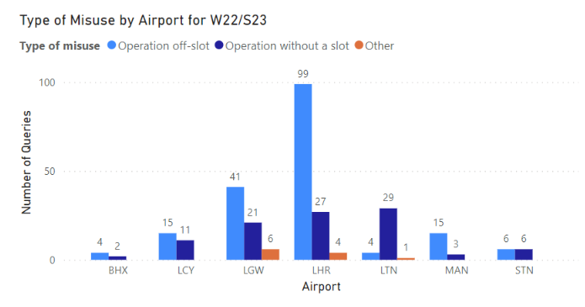

1. Examples of corrective action facilitated by ACL’s monitoring activities

Where possible, ACL engages with carriers to encourage behavioural change to improve future slot performance without the need to formally sanction misuse. This could be increasing block times, retraining of the out of hours process at individual airports or equipment discrepancies such as using a different aircraft to declared slot. Below are a few examples of carriers behavioural changes that have improved slot performance after slot monitoring activities by ACL were highlighted to the carrier.

An example of an equipment discrepancy can be seen at London Gatwick Airport in W22 by British Airways. The airline were using a different aircraft for operation compared to the aircraft declared to ACL resulting in regular off-slot operations. The airline were able to update the correct aircraft and block times which improved the performance of the flight.

A second example seen at London Gatwick Airport in S23 by Air India, shows a change in block time adjustment by 05 minutes improved the performance of the flight.

In S22 at London Heathrow Airport after ACL highlighted the off-slot performance of a Cathay Pacific flight, the airline advised they would monitor wind performance and would hold departure from the arriving airport if wind conditions were to alter the slot performance of the flight into London Heathrow.

These are just a few examples of routine slot performance by ACL that can improve the slot performance of a flight without formally sanctioning misuse to the airline.

1. Sanctions levied for slot misuse

For the period 1 October 2022 to 30 September 2023, ACL levied the following sanctions for slots misuse:

* 22November 2023 - £32,000 sanctioned against Eastern Airways for thirteen operations operating significantly different from the allocated slot at London Gatwick airport during S23.
* 03 January 2023 - £5,000 sanctioned against EasyJet UK for one operation without a slot at London Gatwick airport during W22.
* 30 January 2023 - £2,000 sanctioned against EasyJet UK for one operation without a slot at London Gatwick airport during W22.
* 26 January 2023 - £2,000 sanctioned against Air China for one operation operating significantly different from the allocated slot at London Heathrow Airport during W22.
* 10 March 2023 - £3,000 sanctioned against Iberia for one operation without a slot at London Heathrow airport during W22.
* 13 July 2023 - £4,000 sanctioned against British Airways for one operation without a slot at London Heathrow airport during S23.
* 25 August 2023 - £4,000 sanctioned against British Airways for two operations operating significantly different from the allocated slot at London Heathrow airport during S23.
* 22 September 2023 - £8,000 sanctioned against British Airways for two operations without a slot at London Heathrow airport during S23.
* 17 October 2023 - £5,000 sanctioned against British Airways for two operations operating significantly different from the allocated slot at London Heathrow airport during S23.
* 23 November 2023 - £2,000 sanctioned against Ethiopian Airlines for one operation operating significantly different from the allocated slot at London Heathrow airport during S23.
* 22 December 2023 - £5,000 sanctioned against British Airways for two operations operating significantly different from the allocated slot at London Heathrow airport during S23.
* 24 April 2023 - £2,000 sanctioned against EasyJet UK for one operation without a slot at London Luton airport during S23.
* 17 July 2023 - £2,000 sanctioned against EasyJet UK for one operation without a slot at London Luton airport during S23.
* 22 August 2023 - £2,000 sanctioned against EasyJet UK for one operation without a slot at London Luton airport during S23.
* 03 October 2023 - £2,000 sanctioned against EasyJet UK for one operation without a slot at London Luton airport during S23.
* 17 November 2023 - £44,000 sanctioned against FlyOne for multiple operations operating significantly different from the allocated slot at London Luton airport during S23.
* 29 March 2023 - £1,000 sanctioned against BA Cityflyer for one operation without a slot at London City airport during W22.
* 24 July 2023 - £12,000 sanctioned against BA Cityflyer for multiple operations operating significantly different from the allocated slot at London City airport during W22.
* 15th August 2023 - £1,000 sanction against TUI for operating a slot at a time different to that cleared by the coordinator at Manchester Airport during S23.

1. Independent reviews

Under section 14 of the Enforcement Code, carriers can request an independent review of ACL’s decision to impose a financial sanction for slots misuse. More information on this can be found on our website at <https://www.acl-uk.org/acls-monitoring-sanctions-process/>

Within the W22/S23 period, no independent reviews were carried out.